Difference Between TDD and BDD Methodologies
Introduction
Software development methodologies have evolved to improve quality, reduce defects, and ensure systems meet user expectations.
Two widely used approaches are Test Driven Development (TDD) and Behaviour Driven Development (BDD).
Although both focus on testing and quality, they differ in purpose, process, collaboration style, and application areas.
This document explains their unique approaches, benefits, differences, and when each methodology is most suitable, supported with visuals for clarity.
1. What is Test Driven Development (TDD)?
Definition
TDD is a development technique where tests are written before the actual code. The goal is to ensure all functionalities are validated through automated tests from the very beginning.
TDD Process (Visual)
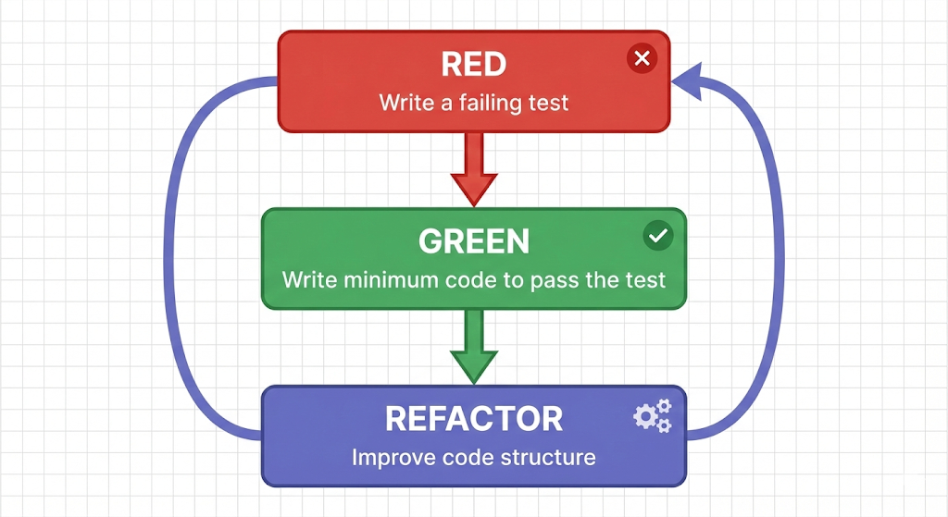
Key Characteristics of TDD
- Focuses on unit-level tests
- Ensures developers think about requirements before coding
- Produces clean, modular code
- Reduces bugs early in development
Benefits of TDD
- Higher code quality
- Fewer production bugs
- Better design due to small components
- Ensures full test coverage
- Facilitates refactoring safely
When to Use TDD
- API development
- Backend services
- Microservices architecture
- Complex logic that requires strict validation

2. What is Behaviour Driven Development (BDD)?
Definition
BDD focuses on how the system behaves from the user’s perspective, describing features in clear, readable language.
It extends TDD by involving developers, testers, and business stakeholders.

BDD Process (Visual)
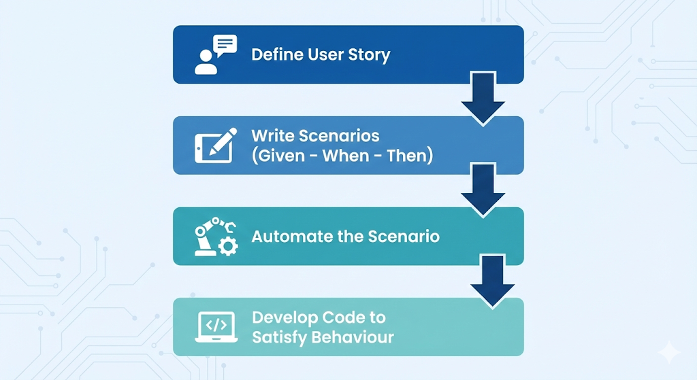
Example of BDD Scenario (Gherkin Syntax)
Feature: Fund Transfer
Scenario: Successful Transfer
Given the user has ₹10,000 balance
When they transfer ₹2,000 to another account
Then the system should show "Transfer Successful"

Key Characteristics of BDD
- Uses natural language understandable by non-technical stakeholders
- Focuses on behaviors, not just functions
- Enhances communication among team members
Benefits of BDD
- Reduces miscommunication
- Creates executable documentation
- Ensures features match business expectations
- Builds user-focused systems
When to Use BDD
- Large teams with developers + testers + business people
- UI/UX-intensive applications
- Projects where requirements frequently change
- Applications requiring acceptance criteria clarity
3. Visual Comparison: TDD vs BDD
Approach Diagram
TDD: Developer-Centric
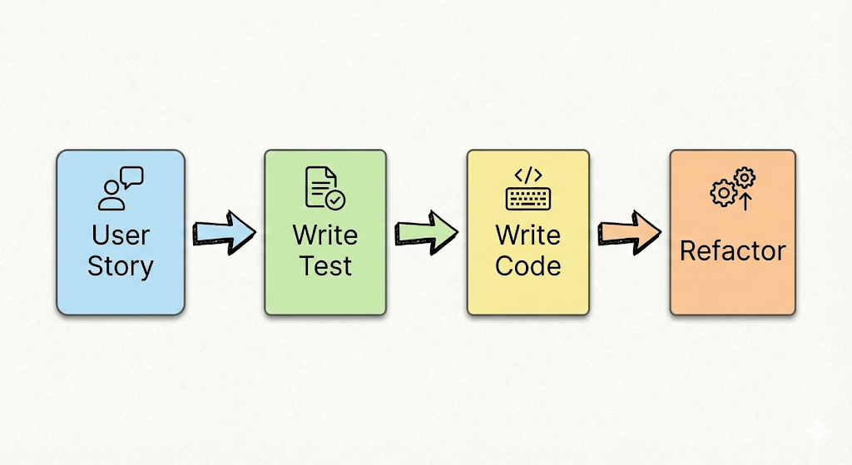
BDD: User-Focused
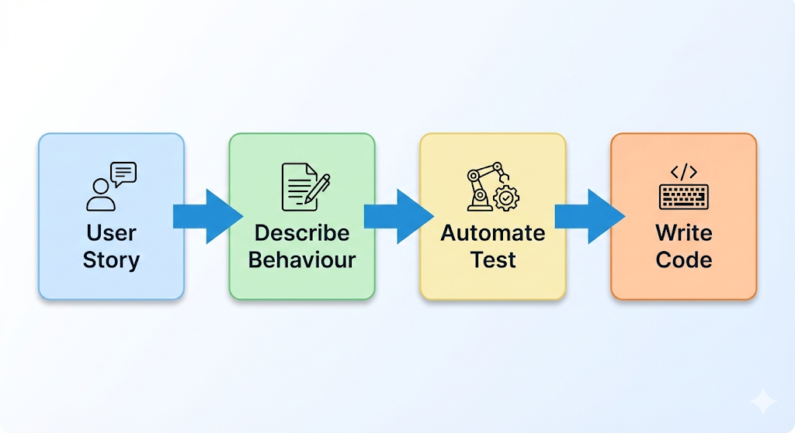
4. Key Differences Between TDD and BDD
Feature | TDD | BDD
Focus | Code correctness | System behavior
Language Used | Programming languages (JUnit, NUnit) | Natural language (Gherkin)
Stakeholder Involvement | Developers only | Developers, Testers, Business
Test Type | Unit tests | Acceptance & behavior tests
Primary Goal | Ensure each unit works correctly | Ensure the system behaves as users expect
Documentation | Technical | Human-readable scenarios
Best For | Logic-heavy backend services | Products with user interactions

5. Suitability in Different Contexts
When TDD is More Suitable
- Projects where reliability and logic accuracy are critical
- Complex algorithms, transaction systems
- Microservices and backend architecture
- Teams with strong technical experience
When BDD is More Suitable
- Applications requiring collaboration across stakeholders
- Systems where user behavior is important (banking apps, e-commerce, portals)
- Projects needing clear acceptance criteria
- Fast-evolving business-driven environments

6. Summary Visual
